**doBCON** steps:

1. Create a new folder under “T24/source/JABLDEV/BCONS” with the record name you want, and a file inside it with the same name that contains component list

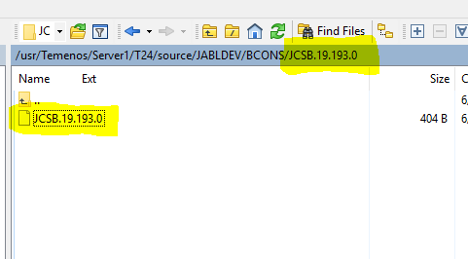

1. It should be formatted as **Application.Name>Record.Name**

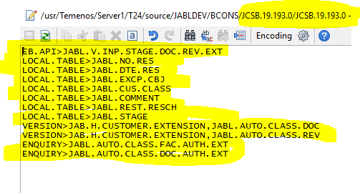

1. Call the command “**doBCON”** with that name of the folder

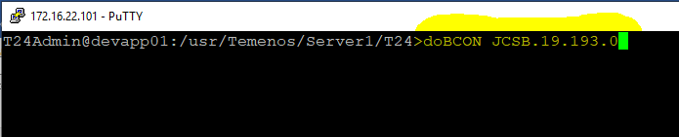

1. You can do other things while it simulates a T24 session, when it ends you will see the green END line

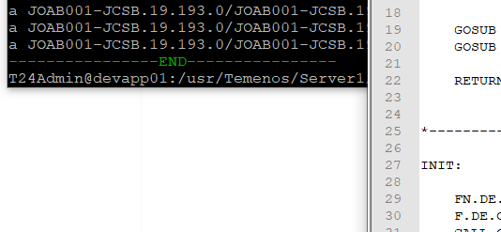

1. Do a refresh to the view of that folder and then you’ll see the tar file

